MEGHNAD SAHA INSTITUTE OF TECHNOLOGY

*Techno Complex, Madurdaha,Beside NRI Complex, Post-Uchhepota, Kolkata 700 150*

LABORATORY NOTE BOOK

MAKAUT EVEN SEMESTER 2023



[BACHELOR OF COMPUTER APPLICATION]

[INTERNET TECHNOLOGY LAB (BCAC591)]

[RUPAK SARKAR]

ROLL NO: 31001221010 REGN. NO.: 213101001210001

STREAM: BCA SEMESTER: V (5TH)

YEAR: 3RD YearSESSION: 2021-2024



MAULANA ABUL KALAM AZAD UNIVERSITY OF TECHNOLOGY



MEGHNAD SAHA INSTITUTE OF TECHNOLOGY

*Techno Complex,. Madurdaha,Beside NRI Complex, Post-Uchhepota, Kolkata 700 150*

“LIST OF ASSIGNMENT/EXPERIMENT SUBMISSION DETAILS”

|  |  |  |  |  |  |
| --- | --- | --- | --- | --- | --- |
| **SL.**  **NO.** | **ASSIGNMENT / EXPERIMENT NAME** | **PLANNED DATE OF SUBMISSION** | **ACTUAL DATE OF SUBMISION** | **CHECKED BY** | **REMARKS (ANY DEVIATION REGARDING SUBMISSION DATES, CONTENT, FORMAT, ETC)** |
| 1. | Create student feedback form in HTML. |  |  |  |  |
| 2. | Create a frame with two windows. |  |  |  |  |
| 3. | Create a frame using name and target attribute tag. |  |  |  |  |
|  |  |  |  |  |  |
|  |  |  |  |  |  |
|  |  |  |  |  |  |
|  |  |  |  |  |  |
|  |  |  |  |  |  |
|  |  |  |  |  |  |
|  |  |  |  |  |  |

|  |
| --- |
| OBSERVATIONS / COMMENTS ON THE OVERALL PERFORMANCE : |

Signature in full with date Signature in full with date

**Faculty / Technical Assistant Lab Examiner**

**Q.1 Create a student feedback form in html (Content) - Name, Contact No., Address, Gender, Cast, Software Language, Stream, hobby. Button - Submit, Reset type.**

<!DOCTYPE html>

<head>

<title>Document</title>

</head>

<body>

<center>

<table>

<h1>Student Feedback Form</h1>

<hr>

<form action="">

<tr>

<td>

<b>Name:</b>

</td>

<td>

<input type="text" maxlength="25" name="name">

</td>

</tr>

<tr>

<td>

<b>Contact Number:</b>

</td>

<td>

<input type="text" maxlength="25" name="phno">

</td>

</tr>

<tr>

<td>

<b>Address:</b>

</td>

<td>

<textarea rows="4" cols="21">Your Address</textarea>

</td>

</tr>

<tr>

<td>

<b>Gender:</b>

</td>

<td>

<input type="radio" name="gen">

Male<input type="radio" name="gen">Female

</td>

<td></td>

</tr>

<tr>

<td>

<b>Caste:</b>

</td>

<td>

<input type="radio" name="caste">

SC/ST/OBC <input type="radio" name="caste">General

</td>

</tr>

<tr>

<td>

<b>Software Languages:</b>

</td>

<td>

<input type="checkbox" name="c">

C<input type="checkbox" name="cpp">

C++<input type="checkbox" name="php">

PHP<input type="checkbox" name="java">java

</td>

</tr>

<tr>

<td>

<b>Stream:</b>

</td>

<td>

<select name="stream">

<option>BCA</option>

<option>MCA</option>

<option>B.TECH</option>

<option>M.TECH</option>

<option>BBA</option>

</select>

</td>

</tr>

<tr>

<td>

<b>Hobby:</b>

</td>

<td>

<select multiple name="hobby">

<option>Singing</option>

<option>Reading</option>

<option>Playing</option>

<option>coding</option>

<option>Drawing</option>

</select>

</td>

</tr>

<tr>

<td>

<button type="submit">Submit</button>

</td>

<td>

<button type="Reset">clear</button>

</td>

</tr>

</form>

</table>

</center>

</body>

</html>

Example:

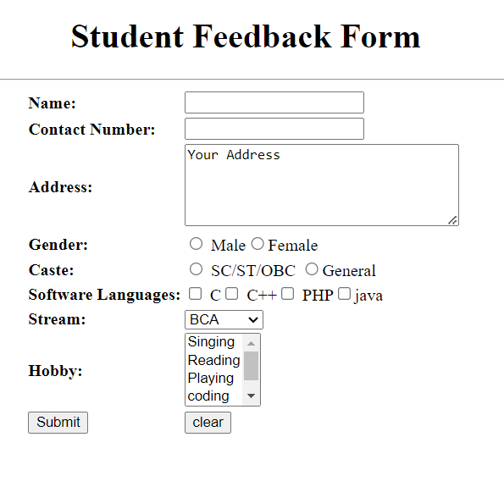

**Q.2. Write a program in html of creating a Frame with 2 windows.**

<!DOCTYPE html>

<html lang="en">

<head>

<meta charset="UTF-8">

<meta http-equiv="X-UA-Compatible" content="IE=edge">

<meta name="viewport" content="width=device-width, initial-scale=1.0">

<title>Document</title>

<frameset cols="25%, 75%">

<frame src="page1.html">

<frame src="page2.html">

</frameset>

</head>

<body>

</body>

</html>

Example:



**Q.3. Write a program in html to create a frame using name & target attribute tags.**

<!DOCTYPE html>

<html lang="en">

<head>

<meta charset="UTF-8">

<meta http-equiv="X-UA-Compatible" content="IE=edge">

<meta name="viewport" content="width=device-width, initial-scale=1.0">

<title>Document</title>

<frameset rows="25% ,50%, 25%">

<frame src="page1.html">

<frameset cols="25%, 75%">

<frame src="one.html" name="frm1">

<frame src="two.html" name="frm2">

</frameset>

<frame src="page2.html">

</frameset>

</head>

<body>

</body>

</html>

Example:

